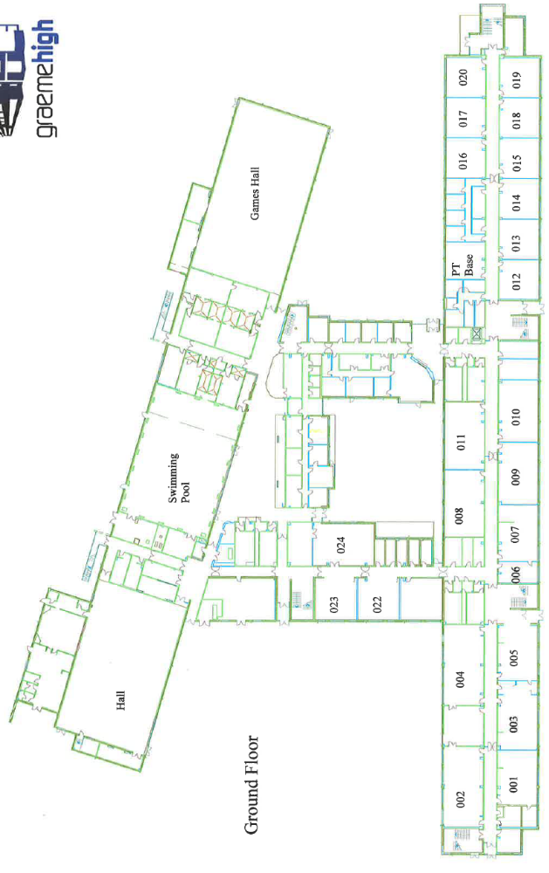
LAURISTON
END
Social Space
5
Medical Suite (Nurse)
M
T
Office
4
Depute Head Teachers
Eco Garden
FALKIRK
END
BUS
AREA
1
T Toilets
PE Meeting Point
6 Maths
4 Drama
3 Music
T
7
5 Design & Technology
6
2 Woodwork
1 Home Economics
2
Assembly
& Lunch Hall
Support Hub
021
3
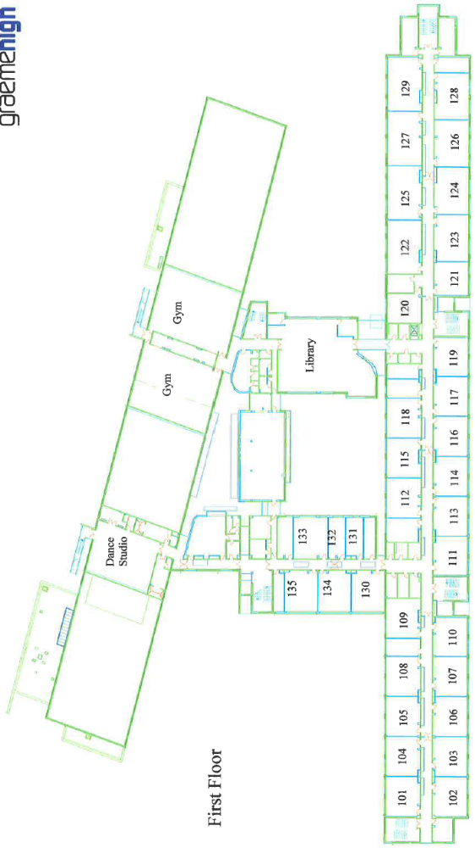
4 RME
3 Learning Zone

5 English
2 Pupil Support Base
8
3
5
6 PE Written Rooms
8 Computing
7 Business Education
1 Social Subjects
2
The Cloud
6
4
7
1

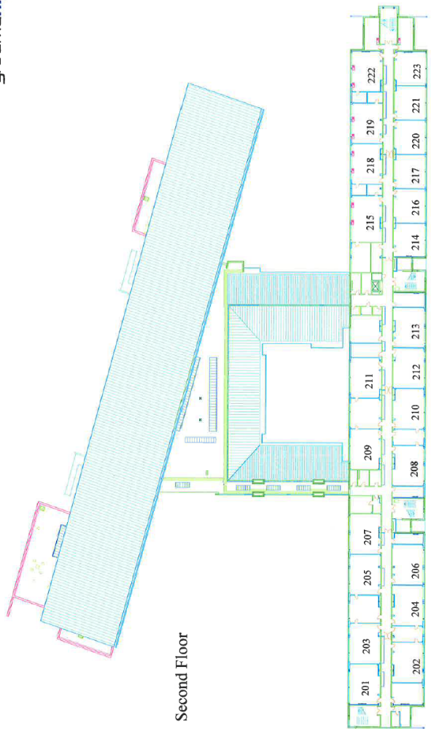
5
House Coloured PSE Rooms
1 Science
4 Art & Design
5 PSE
2 Beauty Salon
3 French
2
3
4
1

