


Graeme High School
Pupil attendance policy

Positive pupil attendance supports learning
In Graeme High School, to support our pupils to Aspire, Attain and Achieve, we have a robust policy and procedures around supporting positive pupil attendance. Good attendance at school supports good personal development and academic achievement. Attend today, Aspire, Attain and Achieve tomorrow. Good attendance at Graeme High School means being in school every day, ready to learn.
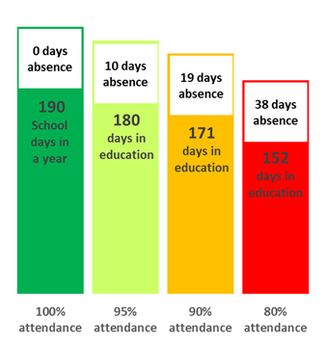
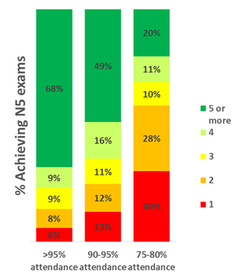
Did you know…
DID YOU KNOW?
A two week holiday in term time means that the highest attendance you can achieve is 94.7%.

DID YOU KNOW?
68% of good attendees achieve 5 national 5 exams. Only 20% of poor attendees (75-80%) achieve 5.
DID YOU KNOW?
If you are 15 minutes late each day you will have missed 2 full weeks of school in one year.


10

15
20
25
5

5
5 minutes late per day = 3 School days
10 minutes late per day = 6.5 School days
15 minutes late per day = 10 School days
20 minutes late per day = 13 School days
25 minutes late per day = 19 School days



Reporting pupil absence
If you are aware that your child is going to be absent, please telephone the school and select the correct option, in advance to have the attendance updated. Alternatively, email our Attendance Officer on Jordana.Opgaard@falkirk.gov.uk. Emails will only be accepted from email addresses that are listed within a pupil contacts record. If this requires to be updated, please contact the office.
When reporting an absence please detail the date(s) of absence and the reason for absence. Please provide details of this rather than simply ‘ill’.
If you expect your child to be absent for a period of time (longer than 5 days), please contact your child’s Depute Head of House to arrange appropriate work to be sent home.

Supporting attendance
To support positive attendance for all of our pupils, there are several daily, weekly and monthly processes that ensure that there are clear lines of communication between parents/carers and the school.

These include –
Daily groupcall for unaccounted absences for both morning and afternoon openings.
Daily phone calls for targeted pupils by our Attendance Officer.
Daily monitoring by all staff of individual absences and period discrepancies – concerns passed to Faculty Heads and Depute Head of House.
Daily monitoring of the accurate completion of registers by teaching staff.

Weekly late reports and groupcall home
Weekly review of attendance patterns and concerns identified

Bi-weekly review of outstanding absences and letters issued.
Monthly review of attendance patterns and concerns identified

Authorised absence
Some absence can be authorised and they will not count against your child’s attendance. Examples of reasons for where authorised absence can be given include:

- participation in non-school debates, sports, musical or drama activities agreed by the school;
- religious observance (for any faith);
- bereavement;
- weddings or funerals for those close to the family (including non-close family members);
- medical and dental appointments;
- appointments with another care provider, i.e. social worker;
- lack of transport, including due to bad weather;
- exceptional domestic circumstances;
- agreed term-time holidays (specific circumstances – see below);
- meetings prior to and in Court;
- attendance at, or in connection with, a Children’s Hearing or Care Review;
- arranged absence in relation to children in Gypsy/Traveller families; and
- period of exclusion
All other absences will be recorded as sickness and will count against your child’s attendance percentage.

Term-time Holidays
All term-time holidays should be regarded as unauthorised unless they meet the following criteria:
- where it is important to the well-being and cohesion of the family (including extended family);
- due to serious or terminal illness, bereavement or other traumatic events; or
- Where a parent’s/carer’s employment is of a nature where school holiday leave cannot be accommodated (e.g. armed forces or emergency services).

The Headteacher makes the decision as to whether or not a term-time holidays meets the above criteria.

Parents/carers requesting a holiday on this basis should submit a request to the Headteacher, by phone, email or letter, before the holiday takes place.

Absences may also be permitted to allow pupils to participate in religious or cultural activities, including travelling to their or their parents’/carers’ country of origin.

Attendance Officer
The role of our attendance officer is –
- Maintaining good records on attendance and providing information and reports to House Teams.
- Monitoring and updating the attendance systems including data input onto school systems particularly relating to school absence.
- Identifying and referring patterns of absence to House Teams.
- Advising teachers of issues in relation to pupil attendance through our school systems.
- Applying agreed procedures in instances of sickness or accident involving a pupil.
- Communicating with parents/carers in relation to pupil absence.
Mrs Opgaard, our attendance officer, may attempt to contact you with regards to your child’s absence. This communication is directed by your child’s DHH so please share any details of absence as requested. Mrs Opgaard also issues groupcall messages and responds to any other matters in relation to pupil attendance.
Groupcall
If your child is absent from school and there has not been a reason for this absence shared with the school, you will receive a groupcall message. Please simply reply to this message to allow us to update your child’s attendance accordingly. If you are unaware of your child being absent please contact Mrs Opgaard as soon as possible to investigate this.

You may also receive a groupcall when your child is late three or more times in a week. On these occasions, please address this with your child to ensure that their timekeeping improves. If there is an issue around this or you or your child requires support around this, please contact your child’s DHH.

Review of outstanding absences
Pupils with outstanding absences will receive a letter home. This will detail their year-to-date, and monthly attendance percentage. As part of this, parents/carers will be able to see the absences relating to their child. If there are absences unaccounted for, please email our Attendance Officer on Jordana.Opgaard@falkirk.gov.uk or call the school on 01324 622576 to update us with the reason for the absence. If you prefer, you may write a note detailing the date and reason for outstanding absences and hand this into our school office.

Understanding the monthly attendance summary
When looking at the attendance summary, each day is split into morning and afternoon openings. Where there is a dash (-), your child has been recorded as present. Where their absence is to be confirmed there will be a T. For other reasons for absence, the following codes are used –
Code | Explanation |  | Code | Explanation
Z | Temporarily off roll/ Extended leave with parental consent |  | B | Medical - Sickness with educational provision
T | Absent - Reason unknown |  | Q | Exceptional domestic circumstances - short term (authorised)
J | Late |  | R | Exceptional domestic circumstances (not authorised)
V | Curricular visit |  | S | Study leave/SQA exams
P | Doctor/Dentist appointment |  | U | Truancy/unexplained absence
X | Exclusion - temporary |  | N | Other Unauthorised Absence
G | Unauthorised Family Holiday |  | W | Work experience
E | Authorised family holiday |  | H | School holiday
O | Provision elsewhere |  | A | Phone call/text notification of absence
D | Medical - Sickness with no educational provision |  | ~ | In school but not in class

Graeme High School
Parents/carers
Attendance - What to expect
Letters home for outstanding absences. Either email or phone to clarify any absences highlighted.
Reply by—text or phone. When writing/leaving a message, please detail reason for absence (not just ‘ill’!)
Phone/email our attendance line and leave a message if you expect an absence (doctors/dentists etc.)
Group call home—based on period 1 attendance. Pupils must sign-in late at the office to avoid incorrect groupcall.

