

HIGHER BIOLOGY

Unit 2 – Metabolism & Survival

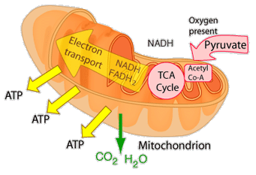

Metabolic pathways and their control

Cell metabolism is the collective term for the thousands of biochemical reactions
that occur within a living cell. Metabolic pathways are controlled by the action of enzymes.
Enzyme a
Enzyme c
Enzyme b
Substance D
Substance C
Substance B
B
Substance A

Metabolic pathways (Page 114)

1. Name the two categories of metabolic pathway.
2. Describe what a catabolic pathway is and give an example of one. (Make reference to energy)
3. Describe what an anabolic pathway is and give an example of one. (Make reference to energy)
4. Copy figure 7.1 ‘Two types of metabolic pathway’ into your notes.

Reversible and irreversible steps within metabolic pathways (Page 116)

1. Explain the benefit of a metabolic pathway having both reversible and irreversible steps.
2. The chemistry of respiration is a complex series of metabolic pathways. Name the first
stage of the chemistry of respiration and describe the metabolic pathway involved,
naming the sugar molecule that starts the process and the final metabolic product.

- Complete the ‘Glycolysis – Reversible and Irreversible Steps’ diagram

3. Explain the benefit of the glycolysis metabolic pathway having an ‘alternative route’.
State when such a pathway would occur.

Related Learning – Disruption of Metabolic Pathways
(Poisons, Toxins & Venoms)

Read the Case Study on pages 114-116 of the Higher Text book. Now answer the questions below.

1. Define the terms poison and toxin.
2. Describe in detail the effects of snake venom on human nervous metabolic pathways
3. Research the weed killer paraquat, finding out when it was developed, what it is used for and the
toxic effects that it has on humans.
4. Research the production of hydrogen cyanide by cyanogenic plants. Find out which plants
produce cyanide and why they produce it. Describe what happens if humans ingest hydrogen
cyanide.
5. Describe the effects and use of poison potassium chloride
The Importance of membranes to metabolism

Every cell has a cell membrane that separates the internal living contents of a cell
from its external surroundings. One function of the cell membrane is to regulate the
flow of materials required for metabolism into the cell and regulate the exit of
metabolic products out of the cell. Cell organelles such as mitochondria and
chloroplasts are also bound by membranes.

Compartmental function of membrane (page 117)

Mitochondrion

The functioning of the mitochondrion depends on the two membranes from which it is made up. The mitochondrion has an outer membrane, which separates it from the rest of the cell contents, and a folded inner membrane, which provides a large surface area for reactions to take place upon.

1. Name the metabolic process that occurs within a mitochondrion.
2. State the name of the two locations within a mitochondrion where metabolic activity
takes place and briefly describe what the activity is.

- Complete the ‘Compartments and membranes of mitochondrion’ diagram.

Chloroplast

The chloroplast is also a double-membrane structure. This membrane forms a compartment and allows specific reactions to take place within the chloroplast. Within the chloroplast are granum which are membrane-bound structures containing photosynthetic pigments.

1. Name the metabolic process that occurs within a chloroplast. Find out the names of the
two ‘areas’ within a chloroplast where the light dependent and carbon fixation (Calvin
cycle) stages take place

- Complete the ‘Compartments and membranes of chloroplast’ diagram.

Membranes can form compartments to localise the metabolic activity of the cell. The high surface to volume ratio of small compartments allows high concentrations and high reaction rates.

Structure of the cell membrane (page 119)

The cell membrane is composed of protein and phospholipid molecules. The
arrangement of these molecules is known as the fluid mosaic model.

1. Describe the arrangement of phospholipids within the cell membrane. Explain why the
phospholipids are described as ‘fluid’.
2. Describe the arrangement of proteins within the cell membrane. Explain why the
proteins are described as ‘mosaic’.

- Complete the ‘Fluid mosaic model of cell membrane structure’ diagram

Function of the cell membrane

1. Define diffusion.
2. Name two molecules that can freely pass across the phospholipid bi-layer.
3. Describe how larger molecules diffuse across the membrane
4. Define the process of active transport.
5. What energy molecule is required for active transport?

Certain protein molecules present in the cell membrane that are involved in actively
transporting ions across the membrane are called pumps.

6. Describe in detail the movement of sodium and potassium ions that are actively
transported across the cell membrane by protein embedded in the membrane.
7. Why is it important that sodium and potassium ions are pumped across the membrane in
this way?
8. State what would happen to the rate of transport of sodium and potassium ions across
the membrane if the following intracellular conditions were to change in the following
ways. Explain the reasons behind each of the changes.

- An increase in temperature from 20⁰C to 30⁰C
- A decrease in oxygen levels
- An increase in the glucose concentrations

Some protein molecules embedded in membranes are enzymes which catalyse metabolic processes essential to the cell. ATP synthase is an example of an enzyme embedded in the membranes of mitochondria and chloroplasts. Its function is to catalyse the synthesis of ATP.

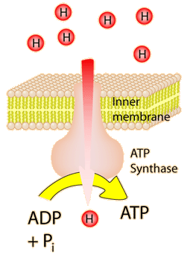

You will find out more about ATP synthase when you study the chemistry of respiration later on in this unit. In the meantime copy the diagram into your notes.

Control of metabolic pathways – Enzymes

Activation energy and enzymes (Page 120/122)

1. Explain what activation energy is?

Enzymes are biological catalysts that speed up the rate of a chemical reaction by lowering the activation energy required for the reaction to proceed. Like other catalysts enzymes take part in the reaction but remain unchanged at the end of it. Enzymes are composed of protein.

2. Copy the following diagram showing the effect of enzymes on activation energy.
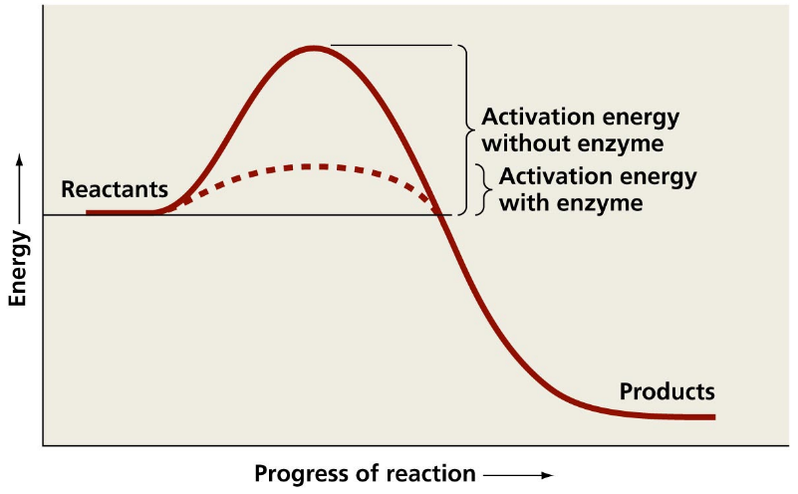

3. Write a short paragraph explaining the importance of enzymes to all living cells. (Page 122)

Enzyme action

The active site of an enzyme is the location on its surface where substrate molecules bind and the chemical reaction takes place. Enzymes are specific and only act on one substrate because substrate molecules are complementary in shape to the enzyme’s active site. Substrates’ are chemically attracted to the active site – they are said to have an affinity for it.

Induced Fit (page 123)

1. Describe the active site of an enzyme in terms of its rigidity and flexibility
2. Describe the induced fit mechanism of an enzyme combining with its substrate and
explain the benefit of this mechanism to enzyme reactions.
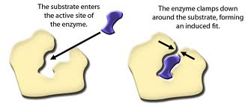

- Complete the ‘Induced fit’ diagram

Orientation of reactants (pages 123 -124)

When an enzyme reaction involves two or more substrates the shape of the active site determines the orientation of the reactants. This ensures that they are held together in such a way that the reaction between then can take place.

Place the following stages that outline the orientation of reactants during an enzyme-catalysed reaction in the correct order

- Products with a low affinity for the active site are released
- Substrate molecules with a high affinity for the active site move towards it
- Enzyme weakens chemical bonds in the reactants and promotes a chemical reaction by lowering the activation energy
- Reactants are correctly orientated into the active site and held closely with an induced fit
Genetic control of a metabolic pathway (page 127)

Enzymes are coded for by genes. Each step in a metabolic pathway is controlled by a specific enzyme. A metabolic block can occur when a gene mutation results in the absence of a functional enzyme. If one enzyme is absent the pathway comes to a halt.

Copy the following diagram into your notes and then answer the questions that follow.

Gene 2 codes for enzyme 2
(Pathway halted due to mutation)
Gene 1 codes for enzyme 1

X
METABOLITE C
METABOLITE B
METABOLITE A

1. State what would happen to metabolite C if a mutation altered gene 2.
2. Under the same circumstances predict what may happen to metabolite B

Related Learning – Phenylketonuria PKU

Read the following information and then answer then complete the PKU diagram from your pack

Each stage in a metabolic reaction is controlled by an enzyme as shown in the example above. Each enzyme is made of protein whose structure and synthesis is determined by genetic information held in a particular gene. If a fault occurs in the genetic information due to a mutation then the enzyme is not produced in its normal functional state. In the absence of the enzyme some essential step in the pathway cannot proceed and an intermediate is often found to accumulate and lead to problems. These disorders are called inborn errors of metabolism and one such example in humans is the phenylketonuria.
Phenylalanine and tyrosine are two amino acids that humans obtain from protein in their diet. During normal metabolism, excess phenylalanine is converted into tyrosine by an enzyme and the pathway proceeds as normal. A person who has PKU has a mutated form of the gene that codes for enzyme 1, this means phenylalanine is not converted to tyrosine and so undergoes an alternative pathway resulting in the build-up of phenyl pyruvic acid which is toxic. If left unchecked it can affect brain development limiting mental development. In Britain, all new born babies are screened for PKU.
Metabolic control by switching genes on and off

Some metabolic pathways are only required to operate under certain circumstances. To prevent resources being wasted, the genes that code for the enzymes controlling each of their stages are ‘switched on’ or ‘switched off’ as required.

Related Learning - Lac operon of E coli (Jacob/Monod)

Your teacher will now present a great example of genes switching on or off to control a metabolic process. You do not require to know the detail of this for your exam.

- Complete the Lac operon diagrams from your pack

Regulation of enzyme activity

The rate at which any enzyme catalysed reaction can proceed depends on a number of factors that include: temperature, substrate concentration and the presence of inhibitor molecules.

.
Effect of substrate concentration on enzyme activity

1. State the effect of a low substrate concentration on the rate of enzyme activity and
explain why this is.
2. Describe the effect of increasing substrate concentration on the rate of enzyme activity
3. Explain why enzyme activity ‘levels off’ when substrate concentration is very high.

- Copy figure 7.20 into your notes

Regulation of enzyme activity by inhibitors

An inhibitor is a substance which reduces the rate of an enzyme controlled reaction. Inhibitors occur naturally but are also produced artificially for uses such as drugs and pesticides. There are two main kinds of enzyme inhibitor:
- Competitive inhibitors
- Non – competitive inhibitor
Competitive inhibitors (page133)

- Describe in detail what competitive inhibitors do and explain why competitive inhibitors reduce the rate of enzyme controlled reactions
- Look at the Figure 8.12 that shows the effect on competitive inhibitors on enzyme reaction rate. What effect does increasing the substrate concentration have on competitive inhibitors?

- Complete the competitive inhibitors diagram

The diagram below shows how increasing the substrate concentration can reverse the effects of a competitive inhibitor

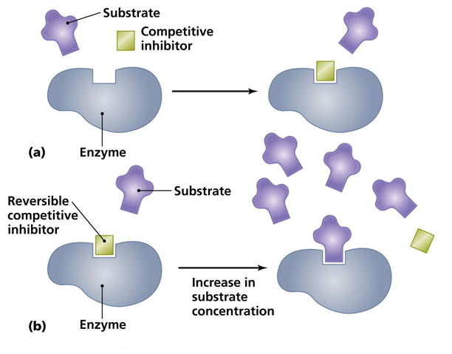

Non-competitive inhibitors (page135)

1. Explain why non-competitive inhibitors are called non-competitive?
2. What is the name of the site on an enzyme where a non- competitive inhibitor
attaches?
3. Describe the effect a non-competitive inhibitor has on the ‘shape’ of the active site
4. Describe the effect of an increasing the number of non-competitive inhibitors on the
rate of an enzyme controlled reaction.

- Complete the non-competitive inhibitors diagram

Overview – competitive and non-competitive inhibitors

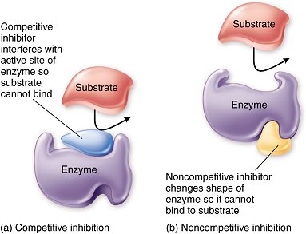

End- product inhibition (pages 135,136)

End product inhibition is another way in which a metabolic pathway can be regulated.
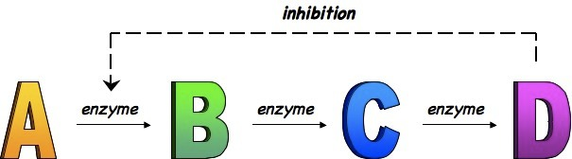

3
2
1

As the end product (in this case metabolite D) concentration builds up some of it binds to enzyme 1 in the pathway inhibiting its actions and thus stopping the pathway from proceeding. As the concentration of the end product falls the inhibition stops and the pathway proceeds. This type of regulation is called negative feedback control.

1. Explain the benefit of end product inhibition.

- Insert the end product inhibition diagram into your notes

Control and regulation of metabolic pathways can be managed by competitive and non-competitive inhibition and end product inhibition.

Cellular Respiration

Cellular respiration is a series of metabolic pathways present in cells from all domains of life. Metabolic pathways of cellular respiration are of central importance to cells. They yield energy and are connected to many other pathways.
Energy
1. Name the source of energy for respiration.
2. Name and describe the high energy compound produced during respiration.

ATP is the link between catabolic and anabolic reactions.

3. Describe what is meant by a catabolic reaction and give an example.
4. Describe what is meant by an anabolic reaction and give an example.

Copy figure 9.2 on p138

Complete the Transfer of Energy diagram, labelling the catabolic and anabolic reactions.
5. Why do organisms not require a vast store of ATP?

Phosphorylation
Phosphorylation is an enzyme controlled process by which a phosphate group is added to a molecule.
1. Give an example of phosphorylation.

Phosphorylation also occurs when phosphate and energy are transferred from ATP to the molecules of a reactant in a metabolic pathway making them more reactive.
2. Give an example of the phosphorylation of a reactant.

Oxidation and Reduction
1. Describe the terms oxidation and reduction.
Glycolysis

Glycolysis consists of a chain of enzyme controlled steps.

1. Where does the process of cellular respiration begin in a cell?
2. State whether oxygen is required for this process.
3. Name the respiratory substrate and product of glycolysis.
4. Explain why the first half of the chain of reactions in glycolysis is referred to as the energy investment phase.
5. Explain why the second half of the chain of reactions in glycolysis is referred to as the energy payoff phase.
6. Name the process ‘intermediates’ undergo during the energy investment phase that leads to the energy payoff phase.
7. Describe the fate of the hydrogen ions released during glycolysis including the enzyme and coenzyme involved and the molecule formed as a result.
Complete the Glycolysis diagram.
Aerobic Respiration
Aerobic Respiration is the production of high yields of ATP from the complete breakdown of glucose in the presence of oxygen.
Citric Acid Cycle
1. Where does the citric acid cycle take place in a cell?
2. State whether oxygen is required for this process.
Pyruvate is broken down into carbon dioxide and acetyl group.
3. Describe the fate of the carbon dioxide produced.
4. Name the coenzyme that combines with an acetyl group to form acetyl coenzyme A.
5. Name the molecule acetyl coenzyme A combines with to produce citrate.
Citrate undergoes many enzyme controlled steps to regenerate oxaloacetate. Carbon dioxide and ATP are produced.
6. Name the enzyme involved in the removal of hydrogen ions and high energy electrons.
7. Name the coenzymes that are involved in the transport of the hydrogen ions and high energy electrons and name the molecules formed as a result.
Complete the Citric Acid Cycle diagram.
Electron Transport Chain
1. Describe what the electron transport chain is and where it is found.
2. State whether oxygen is required for this process.
3. Name the molecules that are passed to the electron transport chain, how they are delivered and where they have come from.
The high energy electrons flow along the chain of electron acceptors and release energy.
4. What is this released energy used for?
5. Name the enzyme that is stimulated to promote the synthesis of ATP from ADP and Pi during the return flow of hydrogen ions into the matrix.
6. When electrons come to the end of the electron transport chain they combine with a final electron acceptor. Name the final electron acceptor.
7. Hydrogen also combines with this molecule. Name the molecule produced as a result.
Complete the Electron Transport Chain diagram.
8. What is the total number of ATP molecules produced from one glucose molecule during aerobic respiration?

Related Learning- Effect of Malonic Acid
Succinate and fumarate are 2 intermediates in the citric acid cycle.
When succinate is converted to fumarate during respiration, hydrogen is released and is passed to the coenzyme FAD.
The reaction is catalysed by the enzyme succinic dehydrogenase. Malonic acid is a chemical that inhibits the action of succinic dehydrogenase.
An investigation was set up to demonstrate the effect of malonic acid on succinic dehydrogenase.
A chemical called DCPIP was used in this investigation as a hydrogen acceptor. DCPIP is blue in colour when it lacks hydrogen and becomes colourless upon gaining hydrogen.
The following apparatus was set up.
Distilled water
Malonic Acid Solution
Mung Beans
A
B
After 24hrs
Dark blue DCPIP
colourless
dark blue
1. Which set of apparatus is the control experiment?
2. What is the purpose of the control experiment?
3. State 2 variables that should be kept constant to ensure a valid result.
4. What feature of the experiment ensured a reliable result?
5. Draw a conclusion based on the results of this experiment.
Fermentation /Anaerobic Respiration
Fermentation (also called anaerobic respiration) is the production of little ATP from the partial breakdown of glucose in the absence of oxygen.
1. Name the stage of respiration which occurs in the absence of oxygen.
2. How many molecules of ATP does fermentation/anaerobic respiration yield per glucose molecule?
3. Write the word equation for fermentation in plant cells and yeast cells.
4. Write the word equation for anaerobic respiration in animal (and some bacteria) cells.
5. Which anaerobic respiration reaction is reversible and which is irreversible?

Substrates for Respiration
Complex carbohydrates, proteins and fats can all be used as respiratory substrates if they are first converted to suitable intermediates able to enter the respiratory pathway.
1. Name 4 complex carbohydrates that can be broken down into glucose and used as a respiratory substrate.
2. State where stores of glycogen can be found in the body.
3. Describe how fat is used as a respiratory substrate and state where it enters the respiratory pathway.
4. Name the process excess amino acids undergo.
5. State where the intermediates formed from amino acids enter the respiratory pathway.

Complete the Substrates for Respiration Summary diagram.

Related Activity- Use of Respiratory Substrates
Read p152 of the textbook and answer the following questions.
1. A person can store 350g of carbohydrate as muscle glycogen and approximately 90g as liver glycogen. After 20-30 minutes of continuous exercise how much carbohydrate in total will be left in storage in muscles and the liver?
2. Calculate the increase in percentage (using the maximum percentage) in the use of protein as a respiratory substrate in the first hour of exercise and during the latter stages of prolonged exercise lasting 5 hours or more.
3. State the order of respiratory substrates used during marathon running.
4. During marathon running, how does a runner reduce the dependency on fat reserves?
5. Why would it be beneficial for a runner to have little fat reserves?
6. What is starvation?
7. When is the only time tissue protein is used as a source of energy?
8. What is the consequence of tissue protein being used as a source of energy?
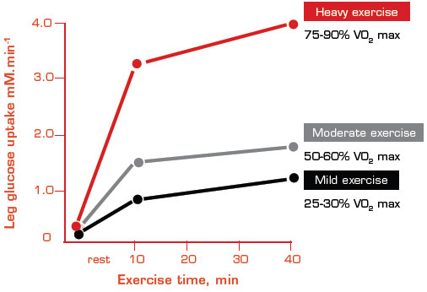

0

9. Using the graph, calculate the percentage increase in leg glucose uptake when exercise is increased from moderate to heavy at 10 minutes of exercise time.
10. Calculate the percentage increase in leg glucose uptake during moderate exercise from 10 minutes to 40 minutes.
11. State the time when leg glucose uptake reaches 1.0 mM.min⁻¹ for each type of exercise.
Maintaining Metabolism

- An organism produces energy during respiration. The quantity of energy consumed by an organism per unit of time is called its metabolic rate. The ability of an organism to maintain its metabolic rate is affected by external abiotic factors.

Measuring Metabolic Rate (page 156)

- Give three ways in which metabolic rate can be measured.
- Describe two machines that can be used to measure an organism’s metabolic rate.
- Give two examples of external abiotic factors that can affect an organisms ability to maintain its metabolic rate.
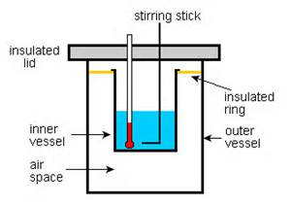
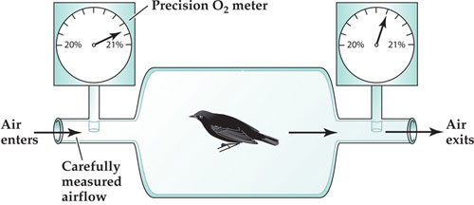

Respirometer
Calorimeter

Oxygen Delivery (pages 158-163)
- State two reasons for which an organism’s metabolic rate may have to increase.
- What is meant by a ‘closed’ circulatory system?
- Describe the main differences between a single and a double circulatory system.
- What are the two different forms of double circulatory systems and how do they differ?

- Complete the circulatory system diagrams.

- Why doo amphibians not rely solely on their lungs for gas exchange?
- Describe what happens when a bird a) inhales air
b) exhales air
- State one physiological adaptation of deep-diving mammals to ensure that they can conserve oxygen whilst deep-water diving.
- How does the human body adapt to life at high altitudes with lesser oxygen levels?
- Describe what is meant by VO₂ max and how it can be measured.

Related Learning – The Weddell Seal

(page162)
- After only a few powerful strokes, how is the Weddell seal able to reach depths of up to 500m?
- Where does the Weddell seal store the majority of its oxygen?
- How is it able to hold such a large volume of oxygen in its blood compared to humans?
- What fraction of its oxygen is stored in its body tissues?
- What is special about the muscles of the Weddell seal that allows them to store so much oxygen?

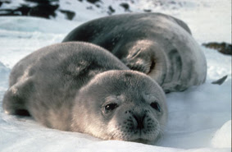
Metabolism in Conformers and Regulators

- Organisms often encounter changes in their external environment (for example: fluctuations in temperature). Some organisms are able to alter their metabolic rate and maintain a constant internal state. These types of organisms are called regulators. Other organisms are not able to do this. These types of organisms are called conformers.
Conformers and Regulators (pages 164-166)
- What is a conformer?
- Describe one advantage and one disadvantage of being a conformer.
- What is a regulator?
- Describe one advantage and one disadvantage of being a regulator.
- Explain how ‘few organisms are complete conformers’.
- Explain how Atlantic salmon are able to live part of their life in salt water and part of their life in fresh water.
- Copy and complete the following passage:

A conformer’s internal environment is dependent upon __________ environment. Conformers tend to have ____ metabolic costs and a ________ ecological niche. Regulators use ________ to control their internal environment which has _____ energy costs, however they are able to occupy a ____ ______ of ecological niches.

- Copy and complete the table – Differences between Conformers and Regulators.

Regulators | Conformers
Possess a constant internal environment by physiological homeostasis | Internal Environment is directly dependent on the abiotic factors of the external environment.
They control their internal environment by negative feedback control | They control their internal temperatures by behaviour mechanisms (e.g. basking in the sun)
They consume large amounts of energy | They consume small amounts of energy
They can occupy a wide range of ecological niches | Less adaptable therefore occupy a narrow range of ecological niches

Physiological Homeostasis

- Physiological homeostasis is carried out by regulators. It is the maintenance of the body’s internal environment within tolerable limits despite changes in the body’s external environment. This regulation is brought about by negative feedback control.

- Describe the role of receptors and effectors in negative feedback control.
Thermoregulation (pages 166-169)
- What is meant by the term ‘thermoregulation’?
- What is an ‘ectotherm’ and give an example of this type of organism.
- What is an ‘endotherm’ and give an example of this type of organism.
- Why do animals with a body temperature ranging between 35-40◦C have an efficient metabolism?
- What is the name of the body’s temperature monitoring centre and where can it be found?
- Where does this centre receive information regarding temperature?
in the skin.
within the hypothalamus.
- Name four effectors which help to return the body to ’norm’.

- Complete the ‘Negative Feedback Control – Thermoregulation’ diagram.

- What two processes help to correct overheating?
- What three processes help to correct overcooling?

- Complete the ‘Vasodilation and Vasoconstriction’ diagram.

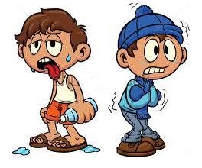

Metabolism and Adverse Conditions

- Many of Planet Earth’s environments change seasonally. The summer may bring increased temperatures, abundant food supplies and sometimes periods of drought. The winter may bring decreased temperatures and a lack food sources. These changes are often not fatal to plants and animals as they have adapted to survive them or avoid them.

- Dormancy (pages 173-176)
- When does dormancy occur and what happens to the organism’s metabolic rate during this period?
- Describe the differences between predictive and consequential dormancy.
- Describe one advantage and one disadvantage to an organism that employs consequential dormancy.
- State two examples of dormancy employed by animals.
- Complete and complete the following passage:
Hibernation is a form of dormancy that enables animals to survive the harsh conditions of _______. In response to _________ day length, the animal creates a _____ __ ___. Aestivation is a form of dormancy that enables animals to survive periods of excessive heat or drought in _______. In both cases, _________ rate is reduced until favourable conditions return.
- How is daily torpor different from the above examples of dormancy?
- Describe one example of an animal using daily torpor and explain why it is crucial to it’s survival.

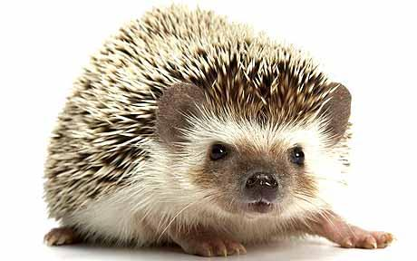

Related Learning - Seed Banks

- Storing seeds in a seed bank is a method of protecting potentially valuable species for future generations.
(page 175)
- Give three examples of the types of valuable species that can be stored in a seed bank.
- Describe the conditions the seeds in a seed bank are kept in.
- Why are the seeds assessed before being stored in a seed bank?
- What are the two potential outcomes of the seed assessment?
- Where can the seeds that are deemed unsuitable for seed bank storage be conserved?
- How is this method not as efficient?
- What does ‘regular monitoring’ of the seeds in seed banks involve?
- Give three examples of information stored in the seeds ‘accurate records’
- With global warming expected to increase, what varieties of seeds are given priority to be banked in the limited storage available?

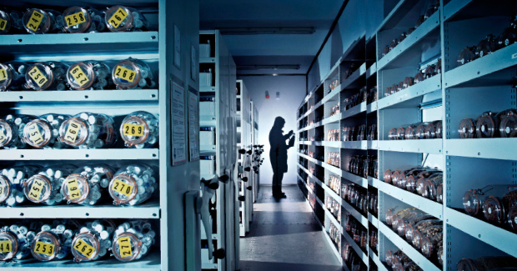

- Migration

- Migration is the regular movement by members of a species from one place to another over a relatively long distance. By expending energy to migrate to a more favourable environment, an animal can avoid metabolic adversity.

(pages 177-183)
- Why do many vertebrates and some invertebrates undergo long distance migration each year?
- Why does the Monarch butterfly migrate north in the summer to the USA and Canada, and then back south again to Mexico in winter?
- What 4 main pieces of information to scientists want to find out when studying long-distance migration?
- Describe three different ways in which organisms can be individually marked when studying their migratory pattern.
- Describe two advantages and one disadvantage of using individual transmitters instead of individual marking.

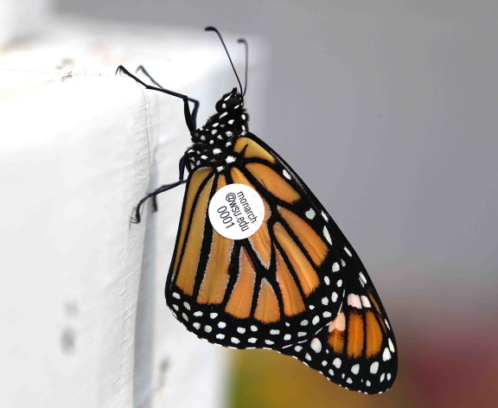

Related Learning – Migration triggers and Adaptations

- Many migratory bird species have adapted to respond to various migration triggers. Scientists have carried out numerous experiments investigating the links between migration and:
- Photoperiod
- The sun
- Internal clock
- The stars
- Magnetic field
(pages 180-181)
- Describe what is meant by photoperiod and how changes in this can trigger migration of the indigo bunting bird.
- Under normal circumstances, what do the indigo bunting birds do prior to migration?
- How do some birds make use of the sun as a trigger for migration?
- What did the results from the ink pad experiment (figure 11.18) reveal?
- Why do starlings change their angle of orientation by 15° per hour?
- How can certain patterns of stars trigger migration?
- When bar magnets are attached to the backs of pigeons they can become disorientated, why?

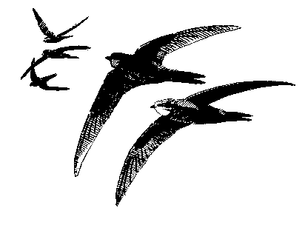

Innate and Learned Influences on Migratory Behaviour

- Migration in animals can be inherited from previous generations and be completely inflexible (unchanging). In this case, every member of the species will exhibit this pattern of migratory behaviour. This is called innate behaviour. Migration behaviour can also be gained by experience and be flexible (it can change). This is called learned behaviour.
(pages 182-184)
- Innate migratory behaviour occurs in a response to what?
- During the bird displacement experiment in Europe, where did the adult starlings end up?
- Where did the young, inexperienced starlings end up?
- What was concluded from the displacement experiment?
- When two populations of nestling blackcap warbler birds were put into funnel cages, what directional choices were made by each population group?
- What did this experiment show about the blackcap warbler’s migration behaviour?
- Copy and complete the following passage:

The ________ gene has been identified as a contributor to migratory behaviour. Scientists believe that this gene accounts for ___% of migratory behaviour in blackcap warbler birds, however, the influence of __________ factors is also important. The ____ ______ repeat at the end of the genetic sequence varies between different populations. It is believed that the more of these repeats, the higher the level of _____-____ restlessness and the ________ he distance travelled during migration.

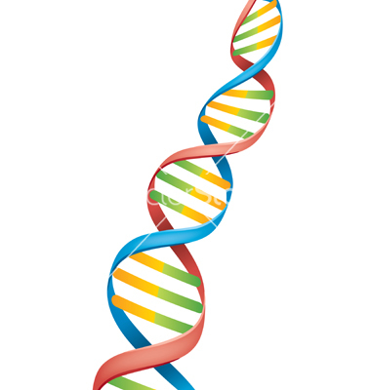
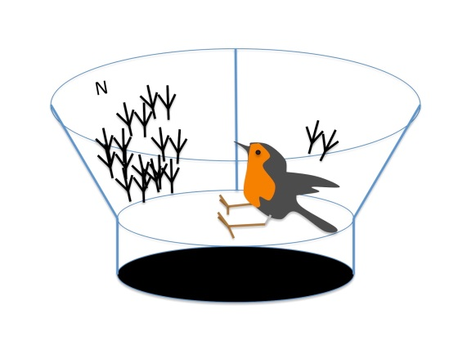

Extremophiles

- Extremophiles are organisms that possess enzymes that are extremely tolerant. This gives them the ability to live in extreme conditions that would be lethal to most other organisms. There are a number of different types of extremophile.
(pages 184-185)
- State the type of extremophile that can survive in temperatures as low as -15°C.
- Which extreme condition can an ‘osmophile’ thrive in?
- In what habitats do thermophiles thrive?
- What useful enzyme can be sourced from thermophiles and what process is this enzyme used in?
- State why all these extremophiles are able to live in such extreme conditions.
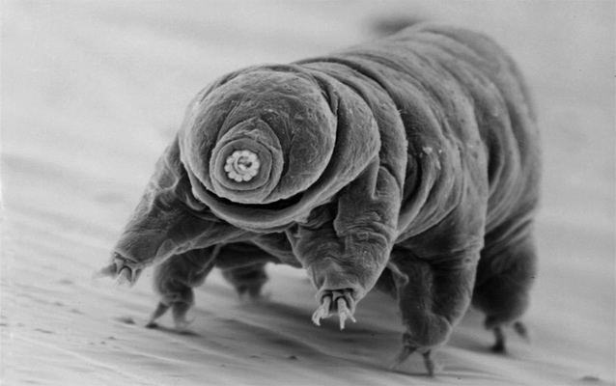
The Tardigrade
This water-dwelling, segmented organism can withstand temperatures from just above 0°C to well above 100°C, pressures about 6X greater than those found in the deepest oceans, ionising radiation at doses of over 100X higher than the lethal dose for a human, and the vacuum of outer space. They can go without food or water for more than 10 years.

Methanogenic bacteria

- Which two gases do methanogens require in order to generate ATP? State the purpose of each gas.
- What word is used to describe methanogens and other organisms that will only thrive in the absence of oxygen?

Sulphur bacteria

- What process are purple and green sulphur bacteria able to carry out? Why can they carry out this process?
- Plants require water as their raw material for photosynthesis as it acts as an electron donor and oxygen is produced. What do sulphur bacteria use as an electron donor and what is produced?

Environmental control of metabolism in microorganisms

Microorganisms can be divided into prokaryotes and eukaryotes.

Prokaryotic microorganisms | Eukaryotic microorganisms
Bacteria – do not have membrane bound nucleus | Algae – able to photosynthesis
Archae – look similar to bacteria but have DNA sequences that code for enzymes that can tolerate extreme temperatures and high degrees of salinity | Protozoa – do not photosynthesis They are motile and use other microbes as their food source
 | Fungi (e.g. yeast) – Do not photosynthesis, usually non-motile and absorb nutrients from their environment

Adaptability of usefulness of microorganisms

1. Explain why microorganisms are considered highly adaptable.
2. Name three useful products that are made by the metabolic activity of microbes.
3. List five reasons why microbes are ideal for use in research and industrial processes.

Growing (culturing) microorganisms

The growth of microorganisms is influenced by the composition of their growth medium and the environmental conditions in which they are being cultured.

The culture media must contain:
- An energy source – an organic substance such as carbohydrate
- Raw materials such as amino acids for biosynthesis of proteins and nucleotides to replicate DNA or RNA
- Specific complex compounds such as vitamins and fatty acids (beef extract can be used)
Environmental conditions:
- Sterility – to avoid contamination from ‘stray’ microbes
- Temperature – a suitable temperature is required to enable the microbes enzymes to be active
- pH – buffers are used to keep the pH within the working range of the microbes enzymes
- Aeration – oxygen concentration must be controlled to regulate the respiration rate of the microbes
- Light – Light must be provided for microbes that photosynthesis
Fermenters (page191 -194)

Microorganisms are used in the production of many useful products such as antibiotics and vaccines. To culture microbes and retrieve their products on a large scale industrial fermenters are used. These fermentation vessels create the ideal culture conditions that can be monitored and controlled at all times.

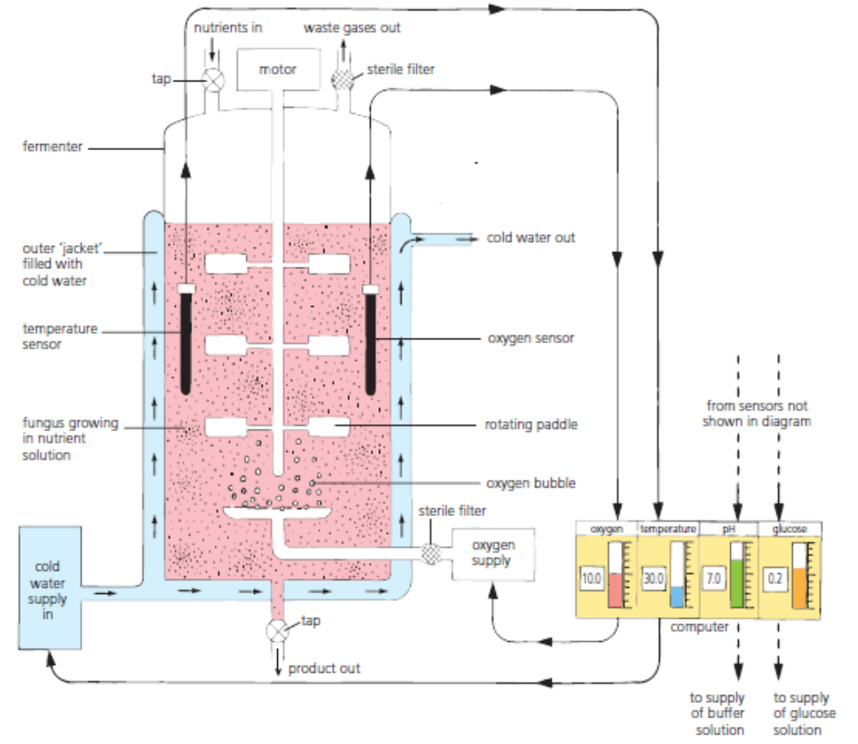
Use the diagram below to help you answer the questions below.

1. Name four types of sensor that an Industrial fermenter would be expected to have.
2. Explain how the fermenter is cooled when the temperature exceeds 30⁰C.

Patterns of microbial growth

Growth is the irreversible increase in the dry biomass of an organism. Growth of organisms such as bacteria and yeast is recorded by measuring the increase in cell number in a given period of time. There are two ways to count cells:

- Total cell count involves counting all cells present in a sample whether dead or alive

- Viable cell count involves only counting the cells that are alive and able to grow. (alive and dead cells can be distinguished by using a dye that only stains dead cells)

Stages of population growth

The time taken for a cell to divide into two is called the generation or doubling time.
When a population of unicellular organisms are grown in liquid medium the use up the nutrients and produce waste products. The way in which they grow falls into four distinct phases:

1. The lag phase
2. The log or exponential phase
3. The stationary phase
4. The death phase

These phases can be represented on a graph.

***Your teacher will now explain what happens during each of these phases**

Write a short paragraph describing the activity of the microbes at each of the four phases

- Complete the stages of microbial population growth from your pack

Log/Exponential phase of growth – presenting data on graphs

During the exponential phase the cells grow and multiply at the maximum rate as long as there are no limiting factors. The cell number resulting from this phase of growth is so large that it becomes difficult to plot on a sheet of normal graph paper.
There are two alternative ways of plotting the population growth

  - Graph with doubling of values on the y axis
  - Graph using semi-log graph paper.

Both these graphs show growth as being at an equal rate and are therefore straight lines.

- Insert the ‘Three ways of graphing exponential growth’ into your notes

Controlling metabolism within microorganisms

Primary and secondary metabolism

Read the following passage and then answer the questions that follow.

Primary metabolism refers to the metabolism of a microorganism that occurs during the lag and log phase of growth. This is when it breaks down the available substrate to obtain energy and produces primary metabolites that can be used for the biosynthesis of substances such as proteins and nucleic acids.
Secondary metabolism occurs at the end of the log phase of growth. Secondary metabolism produces substances that are not associated with growth but which may confer an ecological advantage. Examples of these secondary metabolites include antibiotics, which inhibit the growth of other species of bacteria and so reduce competition for the available resources.
Many secondary metabolites have properties that are extremely useful to humans. Therefore the microorganisms responsible are cultivated on an enormous scale in industrial fermenters in order to mass produce these products.

1. Describe what happens during the primary metabolism of a microorganism in culture.
2. State when the secondary metabolism of a microorganism occurs and say what is not
produced.
3. Give an example of a substance that may be produced by certain microorganisms during
secondary metabolism and explain the benefit of this.

Manipulation of a microorganism’s metabolism - Precursors Inducers and Inhibitors

Microorganisms can regulate their own metabolism by inducing or inhibiting enzymes. When microorganisms are being used in an industrial fermentation process, it is often the case that one particular metabolite is the desired product. The desired product is often not the final product of the metabolic pathway and therefore the pathway may need manipulated to produce large quantities of product. This involves the use of precursors, inducers and inhibitors.

This is best explained by an example. Consider the metabolic pathway below. Metabolite R is the desired product. Copy this down!

This is the precursor. It is acted upon by enzyme 1 to produce metabolite Q. Large quantities of this will be needed
Metabolite P

Enzyme 1

This is the inducer. It is required to bring about the production of enzyme 2.
Metabolite Q

Enzyme 2

DESIRED PRODUCT
Metabolite R

As metabolite R is the desired product and inhibitor that prevents the production of enzyme 3 would be used.
Enzyme 3

Metabolite S

- Now complete the precursor/inducer/inhibitor exercise from your pack and insert in your notes.
Genetic control of metabolism in microorganisms

Mutagenesis (pages 201 -204)

1. Define mutagenesis.
2. Give an example of a mutagenic agent that can induce mutagenesis in bacterium.
3. Describe fully why mutagenesis of microorganisms can be advantageous.

Breeding in microorganisms

1. By which method do microorganisms such as bacteria and fungi reproduce?
2. What does this method of reproduction not give rise to in the offspring?
3. Explain how bacteria can give rise to new strains if they reproduce asexually?

Some bacteria can transfer plasmids or pieces of chromosomal DNA to each other (horizontal transfer) or take up DNA from their environment to produce new strains.
The diagram below shows three ways this can happen. (This diagram is available in your pack, insert it into your notes)
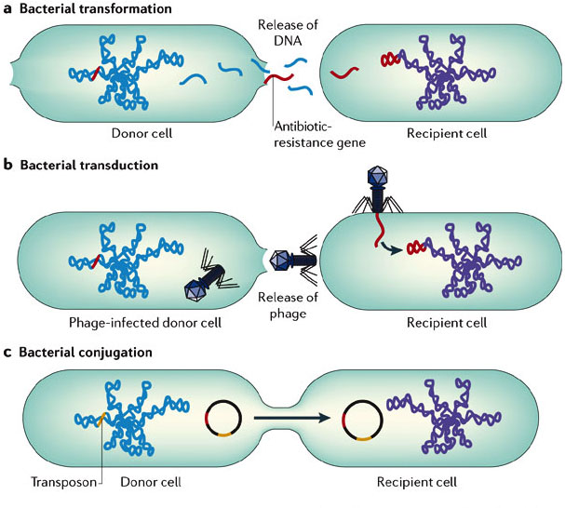

Sexual reproduction in fungi

In fungi and yeast, new strains can be brought about by sexual reproduction between existing strains.

Recombinant DNA technology

Recombinant DNA technology is the process in which a gene from one organism
(e.g. human) is transferred into another organism ( e.g. bacterium). During this process the host organism is transformed and can now produce protein molecules associated with the donor organism.
  - Scientists use plasmids and artificial chromosomes as vectors.
  - As a safety mechanism genes are often introduced that prevent the survival of the microorganism in an external environment.
  - Recombinant DNA technology is dependent on the use of restriction enzymes

Restriction endonuclease (page 209)

1. State what restriction endonucleases are, what they do, and where we get them from.
2. Explain what a restriction site is.
3. When a plasmid is cut open by a restriction endonuclease two ‘ends’ are exposed. What
are they called?
4. Describe exactly the function of DNA ligase in recombinant DNA technology

Plasmids

Plasmids are used as vectors to carry DNA from the genome of one organism (such as a human) into that of another (bacterial host cell). To act as an effective vector a plasmid must have the following features:

  - A restriction site – the site where the donor gene will be placed. It must be able to be cut open by the same endonuclease used to cut out the gene being transported.
  - Marker gene – This gene enables the scientist to determine whether the host cell has taken up the plasmid. A marker gene is often one resistance to a particular antibiotic. If the host cells die then they have not taken up the plasmid.
  - Origin of replication – Genes that control self-replication of the plasmid so that the plasmid can copy itself and appear in all the bacteria being cultured.

Copy figure 13.10 into your note

Recombinant DNA Technology – The complete process (page 208)

- Complete the recombinant DNA technology diagram from your pack
- Learn the steps

Limitations of prokaryotes in Recombinant DNA technology (page 210)

1. Explain why a gene from a eukaryotic cell may not always be expressed correctly when inserted into a prokaryotic cell. (Discuss post translational modifications)
2. Describe how this problem could be overcome.

Ethical considerations in the use of micoorganisms

The use of microorganisms in biotechnological processes such as recombinant DNA technology has raised ethical issues with public interest groups arguing the risks outweigh the benefits.

- Construct a table with the same headings as the one below. Then sort the bullet points that follow into the correct category with the counter argument opposite

Arguments against recombinant DNA technology | Counter argument

- Microorganisms carrying a dangerous gene may escape or be stolen
- It is expensive to develop the genetically modified microorganisms. If patents cannot be taken out, companies will not invest in the technology
- Genetically modified organisms or gene sequences should not be the property of the companies that develop them, but should be available to all.
- Manufacturers carry out detailed risk assessments and maintain suitable standards to ensure that manufacturing processes and products are safe.
- It might improve nutrition and food security by increasing quantity and quality of food.
- The potential impact of the technology is unknown and many aspects of it such as the safety of foods or drugs remain to be understood.

Risk assessment

Many types of microorganism are used in biotechnological industries, some of these can cause allergy or irritancy and be pathogenic (disease causing). For this reason there are many regulations which require detailed risk assessments to be produced and adhered to. The purpose of risk assessment is to remove or minimise a hazard when carrying out a microbiological procedure.

