
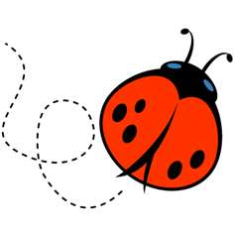

NATIONAL 5 BIOLOGY

UNIT 3: LIFE ON EARTH
SUMMARY BOOKLET

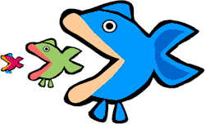


Biodiversity and the distribution of life

Biodiversity is the variety of life in the world or in a particular habitat or ecosystem.

Habitat is the area where an organism (or group of organisms) live.

Community is all of the organisms (plants and animals) living in a habitat

Population is the total number of one species of plant or animal in a habitat

Healthy communities have high biodiversity (lots of organisms living there)

The biodiversity in a habitat will depend on factors which can be divided into 3 categories;
- Biotic
- Abiotic
- Human Influences

1. Biotic factors are living factors that affect organisms in their habitat.
Examples of biotic factors are grazing and predation, because they are both processes carried out by living organism
Low levels of grazing cam lead to a reduction in plant diversity as it allows the
emergence of a dominant plant species to take over at the expense of less
dominant species. High to moderate levels of grazing maintain or increase plant
biodiversity by keeping dominant species in check.

The effect of predation on the prey species can be charted in a predator prey graph like the one shown below. You can see that the numbers in the population of each go in cycles and are dependent on each other.
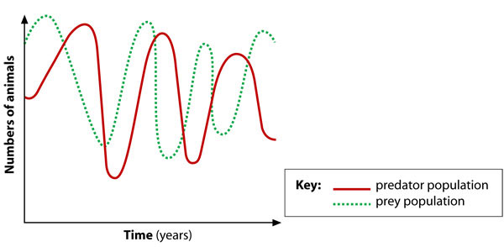

2. Abiotic factors are non-living factors that affect organisms in their habitat.
Examples of abiotic factors are pH, temperature and light intensity.
These factors will affect which animals and plants are present in an ecosystem.

3. Human influences are things that humans do which affect the biodiversity of a particular habitat.

Examples of human influences are pollution of air and water, habitat destruction by deforestation, habitat destruction leading to desertification, overhunting of endangered species and overfishing.
The human activities listed above all result in a decrease in the biodiversity in an area.

Biomes

Biomes are regions of the planet which are distinguished by their climate, (mainly temperature and rainfall) flora and fauna
(flora and fauna describes the plants and animals which live there, the community.)
Some examples of biomes are;
- Tundra
- Forest (e.g. coniferous, deciduous or rainforest)
- Freshwater
- Marine ( e.g. coral reef)
- Desert
- Grassland (e.g. savannah in Africa)

Within each biome there are different regions, these called ecosystems.

An ecosystem is a biological unit made up of the habitat and community.
i.e. it is made up of the living and the non-living components of an area.

An ecosystem is a smaller unit than a Biome, Biomes extend across and between countries, where an ecosystem could be a pond or a local area of woodland.

A Niche is the role an organism plays in its community.

It includes;
- The use it makes of resources
Does it need / use light? (Usually more important for plants)
What temperature does it require to survive?
Which nutrients does it use?

- Its interactions with other organisms
What does it eat (prey)?
What eats it (predators)?
Is it a host for parasites?

Energy in Ecosystems

A food chain is a series of organisms which depend on each other for food (energy). Often food chains are represented by diagrams with arrows, where the arrow shows the direction of energy flow.

Microscopic Microscopic Salmon Brown Bear
plants animals
Primary consumers
Tertiary consumers
Secondary consumers
Producers

All food chains start with a plant, the reason for this is that plants are producers, they use light energy from the sun to make their own food by photosynthesis. Animals cannot make their own food, so can only obtain energy by eating plants, or by eating other animals. They are consumers.

During an animal’s lifetime it eats a lot of food and so produces a lot of energy, however, when it consumed (eaten) not all of the energy is passed on to the consumer (the animal which ate it).

During its lifetime an organism will use energy for;
- keeping itself warm (heat energy)
- moving around (kinetic energy)
- building it’s tissues (potential energy in bones, muscles etc.)
When an organism is consumed the consumer will only get energy from the tissues it eats. This means that most of the energy that the prey has made over its lifetime is not passed on and is lost as it has been used to; make heat, for movement or in undigested food in faeces.

Only 10% of energy is passed on to the consumer, meaning at each stage of the food chain 90% of the energy is lost.
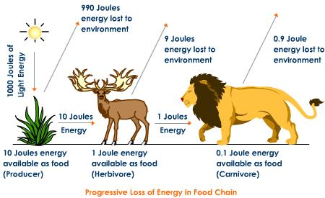

Sometimes scientists use diagrams to show how efficient food chains are. There are 3 types of diagram used;
- Pyramid of Numbers
- Pyramid of Biomass
- Pyramid of Energy

Pyramid of Energy
Gives information about the energy content of all of the organisms in each level of the food chain

This shows that there is more energy available in the producer (oak) than the population of caterpillars, and that the population of blackbirds has less energy than the caterpillars.

Pyramid of Biomass
Gives information about the total mass of all of the organisms in each level of the food chain

This shows that although there is only one oak tree, its mass is much bigger than the mass of all the caterpillars added together, and that in turn is bigger than the mass of all of the black birds.
Pyramid of Numbers
Gives information about the total number of organisms in each level of the food chain

This shows that there is less oak trees (or only one) and that the number of caterpillars is less than the number of black birds.

Caterpillar
Black Bird
Oak tree

Black Bird
Black Bird
Caterpillar
Caterpillar

Oak tree
Oak tree

The diagram on the next page gives another example of some of the similarities and differences. The particular food chain being studies will dictate which type of pyramid best demonstrates the reduction as you move up the food chain.
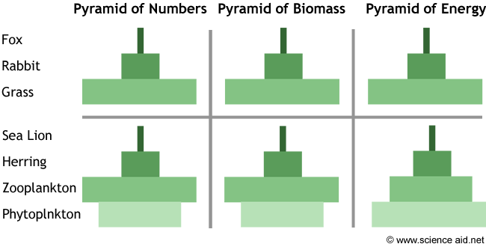

Nitrogen in Ecosystems

Nitrogen is a very important element for all living things as it is one of the 4 elements which join together chemically to make protein (needed to make muscle and enzymes) which is part of every living organism.

There is a fixed mass of Nitrogen of planet, we can only recycle the nitrogen we have, we cannot make ‘new’ Nitrogen. This means that when a plant or animal dies the nitrogen needs to be released so that it can be reused to make more organisms. The Nitrogen cycle describes how Nitrogen is re-cycled. This diagram shows a basic Nitrogen cycle which applies to most plants. However there are some special organisms which help listed on the next page.

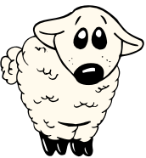
Animal eats plant it uses plant protein to build animal protein
When organism dies decomposers convert protein and nitrogenous waste to ammonium
Nitrifying Bacteria convert ammonium to nitrite
Nitrate absorbed by plants to make all animal and plant protein
Denitrifying bacteria convert nitrate into nitrogen gas in air
Nitrifying Bacteria convert nitrite to nitrate
Nitrogen fixing bacteria; Nitrogen from the air to Nitrate

Micro-organisms (bacteria and fungi) play an important role in the Nitrogen cycle. There are different bacteria which play different roles in the cycle. The following stages involve microorganisms;
- Nitrogen fixation (Nitrogen (gas) Nitrate)
- Nitrification (Ammonium Nitrite Nitrate)
- Denitrification (Nitrate Nitrogen (gas))
- Decomposition (Protein and nitrogenous waste Ammonium)

NITROGEN FIXING BACTERIA
Nitrogen fixation is carried out by specific bacteria. These bacteria trap nitrogen from the air (which is generally very unreactive) and convert it to Nitrate which can be used by plants to make protein. There bacteria can be classified under 2 headings discussed below;
Root Nodules
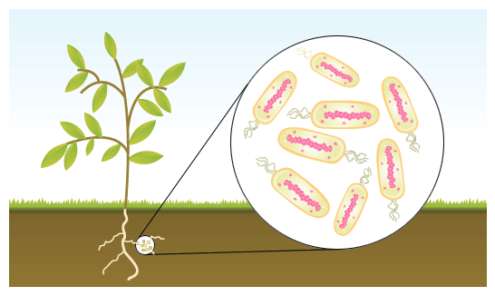
Some plants (e.g. peas and clover) have nodules in their roots which provide a habitat for certain nitrogen fixing bacteria. These bacteria always live in the root nodules, and provide the plant with nitrate for building protein in return for the plant providing a habitat for the bacteria.

Free-fixing bacteria
Sometimes nitrogen fixing bacteria live ‘free’ in the soil where they convert nitrogen from the air into nitrate that can be absorbed by plants to use for making protein.

NITRIFYING BACTERIA
These bacteria are living free in the soil. Some of them are able to convert ammonium compounds into nitrite, others are able to convert nitrite to nitrate.

DENITRIFYING BACTERIA
Too many of these bacteria are bad for an ecosystem as they cause the loss of nitrogen from an ecosystem. Denitrifying bacteria cause nitrate in the soil to be turned into nitrogen gas in the air (where it is not able to be used to build protein in living things).

DECOMPOSITION
Decomposition is the breakdown of compounds from dead matter or from waste materials (urine / faeces). Decomposition is a process which involved bacteria and fungi and results in the production of ammonium for nitrification.

Competition in Ecosystems.

A species is a group of organisms which can breed together to produce fertile offspring.

All organisms compete for resources with other organisms to improve their chances of survival.
INTRASPECIFIC competition is competition for a resource between members of the SAME species.
e.g. 2 Robins competing for territory or 2 beech trees competing for light

INTERSPECIFIC competition is competition for a resource between members of DIFFERENT species.
e.g. A Pigeon and a Seagull competing for food

Animals typically compete for food, habitat, and water.

Plants typically compete for minerals, water, and light.

Sampling techniques and measurement of abiotic and biotic factors

Abiotic factors include pH, light intensity, soil moisture and temperature.

pH can be measured using a pH meter with a probe or by taking samples and testing with an indicator (chemical test).

Light intensity can be measured using a light meter with a sensor which gives information about the light intensity (usually measured in lux).

Soil moisture can be measured using a moisture meter with probe and gives us information about the water content of the soil.
Meter
Temperature is measured with a thermometer, this could be a traditional thermometer, or a digital thermometer with a temperature probe.
Probe

For any of the techniques mentioned above which use a probe this requires particular care as the results can be wrong if the probe is not cleaned thoroughly between each measurement.
Biotic factors include grazing and predation. In order to find out about the biotic factors in an ecosystem we can sample the organisms in that habitat to get information which helps us to understand how many of each population is present.

Quadrats – used to sample plants or very slow moving organisms.
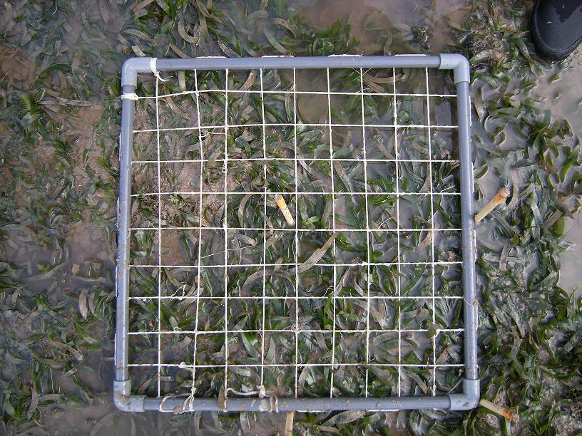
A quadrat is a square grid with known dimensions (i.e. often 1m square)
A quadrat is thrown at random over several sites within a known area and each time the number of plants of a specific species is counted.
An average is calculated and this can be multiplied by the area to estimate the number in the whole area.

It is important that the sample areas are selected randomly when using a quadrat to avoid over-estimating or under estimating
abundance.

Pitfall traps – are used to sample small invertebrates which live on the surface of soil.

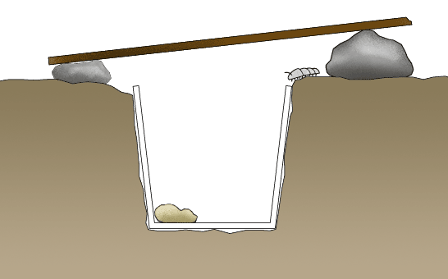
A plastic contained is used and is buried in the soil so that the level of the top of the cup is the same as the soil. It may be covered to stop bigger predators (e.g. birds) from eating the insects in the trap.

One of the problems with these traps is that sometimes the insects may eat one another in the trap making it impossible to accurately assess the full range of species present. Sometimes alcohol is added to the bottom of the trap to alleviate this problem as this kills all of the insects in the trap, which means it is possible to see all of the insects caught.

Adaptation, natural selection and the evolution of species

Mutations
A mutation is a random change in the genetic material possessed by an organism. Mutations occur at random in a population when there are mistakes during the copying of DNA when new cells are produced.

Some mutations can lead to an organism having an advantage over others, others lead to an organism having a disadvantage and others are neutral as they do not give an advantage or a disadvantage in terms of survival.

Mutations occur entirely at random and cannot be predicted. New variations of genes (new alleles) only occur as a consequence of mutations within a species.

Environmental factors such as exposure to radiation (e.g. UV radiation) and some chemicals (e.g. mustard gas) increase the rate of mutation, these are referred to as mutagenic agents.

Variation
Variation is the differences between members of a population. Within the human population there are many examples of variation including height, weight, eye colour and skin colour.

Variation within a population allows it to evolve over time in response to changing environmental conditions.

Natural selection / survival of the fittest

Over a very long period of time species change as a consequence of natural selection, the process is outlined in the steps listed below.

More offspring are produced by the population than the environment can sustain

Only the individuals which are best adapted to the environment will;
i.) Survive
ii.) Reproduce

The genes of these ‘better adapted’ individuals will be passed on to the next generation

Over many lifecycles this can lead to huge changes to the characteristics of a species.
Speciation
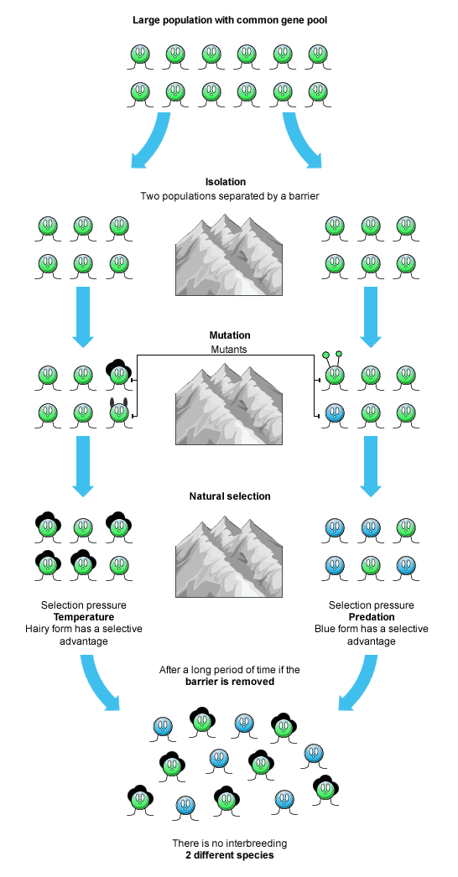
Speciation is the development of a new species of organism.
A species is defined as a group of organisms which can interbreed to produce fertile offspring.
New species are created when a population is separated by an isolating mechanism (e.g. land masses being separated by sea water)
After the populations are separated natural selection will occur within each of the sub-populations. Because the conditions are likely to be different in each habitat, the selection pressures will be different. This means that different characteristics will be favourable in each population, resulting in the development of different characteristics each sub-population.
After many lifecycles (a long time) if the 2 populations were re-introduced they would no longer be able to interbreed and produce fertile offspring, so would no longer be the same species.

Human impact on the environment

The human population is increasing every day as the birth rate is higher than the death rate. The graph below shows how the world population of humans has increased since 1750, based on current trends it is predicted that by the year 2050 the global population will be in excess of 10 billion (10, 000, 000, 000).
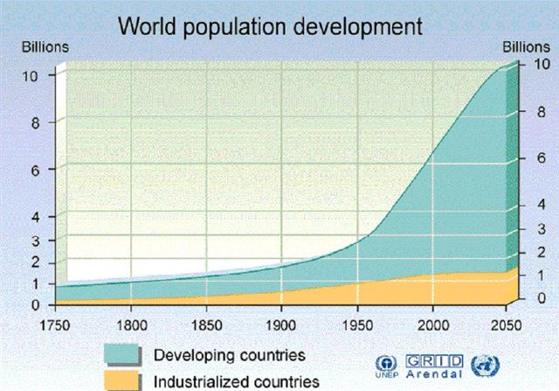

The massive increase in the number of people on the planet puts a lot of pressure on the available resources. In order to continue to feed everyone on the planet the amount of food produced by farmers has to increase.

Some of the methods used to increase food production are;

Using chemical fertilisers.
Chemical fertilisers are added to the soil to increase the number of plants which can be grown.
The problem with using fertilisers is if they are washed from the fields (if it rains) they can get into waterways (rivers and lochs). This can lead to the formation of ‘algal blooms’ where lots of algae grow and take over a patch of fresh water. This leads to a reduction in the oxygen available in the water and causes other species which live there to die.

Using pesticides
Pesticides are chemicals which are sprayed onto crops to stop them from being eaten by insects, and therefor leaving more of the crop for humans.
Unfortunately, pesticides can build up (accumulate) in the tissues of the organisms which eat them. As these organisms are eaten the pesticide will accumulate more in the body of the next organism in the food chain. This means that by the time you get to the top of a food chain there might be so much of the chemical present that the organism at the top is poisoned.

Biological control

Biological control means using living organisms to control pest species instead of applying chemicals. This usually involves the use of;
- A predator which will reduce numbers of the pest species
(e.g. Use of ladybirds to eat aphids, smaller insects which can damage crop species)
- Introduction of a virus/bacteria which will kill the pest species
(e.g. The introduction of the myxomatosis virus to the rabbit population to control rabbit numbers)

GM crops

Scientists are able to genetically engineer crops to increase their productivity (the amount of food available from each crop), make them resistant to disease and make the
more nutritional. An example of this is the ‘golden rice’ project in which scientists have
engineered rice which produces a substance similar to Vitamin A and so improves the
health of children and adults who eat a lot of rice and have a diet lacking vitamin A.

Indicator species

Indicator species provide us information about the level of pollution in their environment by their presence or absence in that environment.
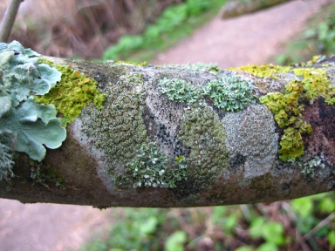
E.g. Lichen.
Lichens grow on trees in areas where there are low levels of air pollution. Lichens are sensitive to the pollutant gas sulphur dioxide. The cleaner the air the more ‘bushy’ the lichens are. In heavily polluted areas no lichens will grow.

E.g. Freshwater invertebrates.
The level of pollution in freshwater is indicated by the freshwater invertebrates present.

The stonefly nymph only lives in water with no pollution that has a high oxygen content whereas the sludge worm lives in polluted water which has a low oxygen content.
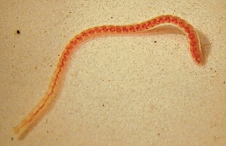
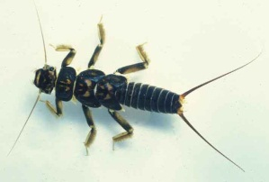
Sludge worm
Stonefly nymph

